Inventory adjustment
* Parentheses are unbalanced: the customer isn’t using serialized items so will need to rearrange the saved search potentially or make use of multiple saved searches (how did u fix this?)
* Customers items have hidden bin inventory from a bin that is inactive (how did u fix this on customer environment?)
* Customers items wasn’t returning current bin available quantity (how did u fix this on customer environment?)
* Inventory adjustment from the UI, change the format of the date or perhaps i can add a step to reformat the date
* I think the script needed a mandatory subsidiary, so if we do not provide one it will still crash, dont know if there is other possibllity to fix this.
no se puede usar una subsidiaria genérica, porque el cliente no tiene acceso a estos campos y tampoco se le pasa información de la UI, el script tiene un error pero debería poder procesarlo.
Básicamente no podemos usar la subsidiaria.
Buscar en el código donde tengo que borrar esto para arreglarlo

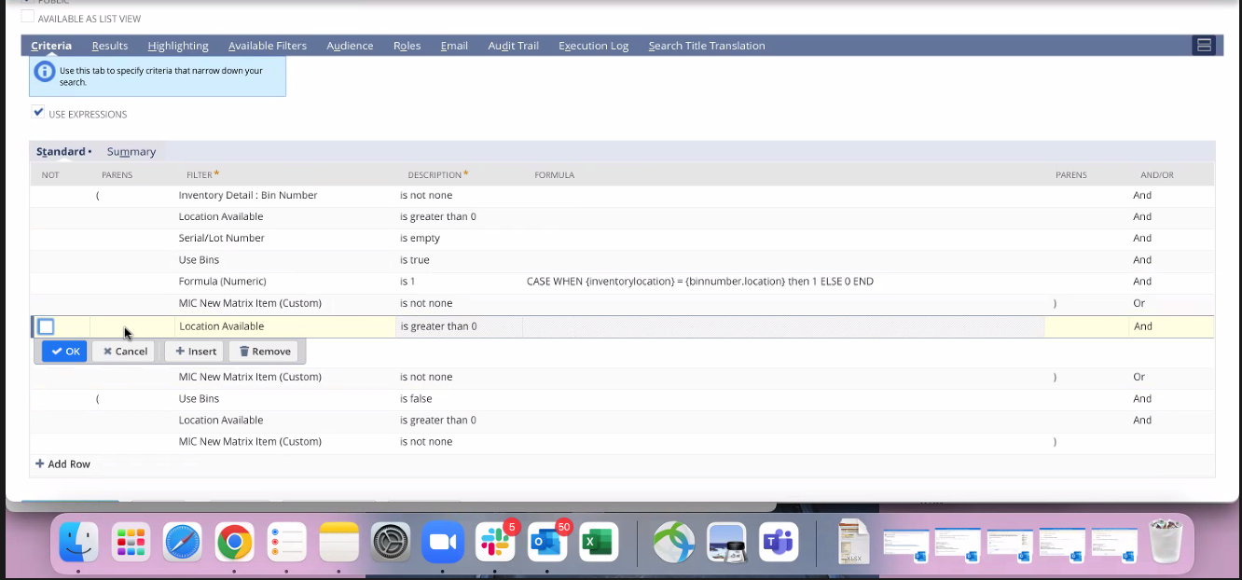
Eliminan una fila que no se usa de serial bins ahí y queda sin paréntesis, y hay que arreglar eso.

Ask if they can forward you a parameter or something to know if we should use subsidiaries or not.
Ask where the new inventory adjustment version is.
Ask if locationNames array empty is okay like that, I feel is not working.
Ask whether we need locations or not.

Add a custom field to the script (which is going to be subsidiaries)
Para testear:
Editar el deployment luego, Save and execute the script, then remove the inventory adjustment.

Descargar la version de custscript_mic_inventory_adjustment_sub que esta en sb2dc y pegarlo en el cliente. (ya fue hecho)
Agregar el custom field de subsidiaries.

Agregar el valor de :
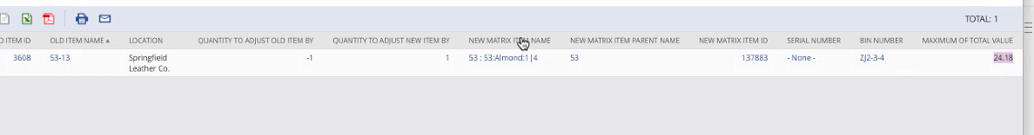
Estimated unit costing, populate it with the same value from the old item.

Para esto, me paro en la línea 1 del inventory adjustment y le seteo el unit cost, no se lo seteo al record de newItem, sino a la línea uno seleccionada del inventory adjustment:
inventoryAdjustmentRecord.selectLine({
sublistId: 'inventory',
line: 1
});

inventoryAdjustmentRecord.setCurrentSublistValue({
sublistId: 'inventory',
fieldId: 'unitcost',
value: data.estimatedUnitCost
});

